

UNIVERSITAS INDONESIA

THE POLLUTION HAVEN EFFECT OF THE ASEAN-CHINA FREE TRADE AGREEMENT (ACFTA):
EVIDENCE FROM INDONESIA’S MANUFACTURING SECTOR EMISSIONS

UNDERGRADUATE THESIS

BERNADETTE GABRIELA WIDYADI
2206065511

FACULTY OF ECONOMICS AND BUSINESS
UNDERGRADUATE PROGRAM
DEPOK
2026

TABLE OF CONTENTS
TABLE OF CONTENTS 2
CHAPTER 1 6
INTRODUCTION 6
1.1 Background 6
1.2 Problem Statement & Research Gap 10
1.3 Research Questions 11
1.4 Research Objectives 11
CHAPTER 2 13
2.1 Trade and Environment Theory 13
2.2. The Environmental Kuznets Curve 14
2.3. The Transmission Mechanism 16
2.4. Review of Empirical Studies 18
2.5. Conceptual Framework and Hypotheses 19
2.5.1. Hypothesis Development 21
CHAPTER 3 22
3.1 Data set and Unit of Analysis 22
3.1.1. Regional-Sectoral Data (Model 1) 22
3.1.2. Domestic-Product Data (Model 2) 23
3.2 Variable Estimation and Operationalization 24
3.2.1. Dependent Variables 25
3.2.2. Variables of Interest (Treatment and DiD Interaction) 26
3.2.3. Control Variables 27
3.3 Empirical Strategy and Econometrical Model 27
3.3.1 Model 1: Regional Sectoral Analysis 28
3.3.2 Model 2: Domestic Product Validation 29
3.4. Identification Assumptions and Robustness Checks 29
3.4.1. Parallel Trends Assumption 29
3.4.2. Robustness Strategies 30
REFERENCES 31

CHAPTER 1

INTRODUCTION

Background
The relationship between international trade and environmental quality remains one of the most debated topics in economic literature. This complexity was first systematically explained by Antweiler, Copeland, and Taylor (2001) who broke down the impact of trade into three distinct channels. These are the scale effect where increased economic activity raises total emissions, the technique effect where rising incomes drive demand for cleaner technologies, and the composition effect where economies shift their industrial structure based on comparative advantage. While early theories suggested that free trade could be good for the environment, subsequent evidence reveals a more complicated reality for developing nations. Studies by Cole and Elliott (2003) and Managi et al. (2009) highlight that the net impact depends heavily on a country’s regulation stringency. This debate leads to the Pollution Haven Hypothesis, which argues that trade liberalization might encourage the relocation of pollution-intensive activities from countries with strict standards to developing nations with laxer regulations (Copeland & Taylor, 2004).
This theoretical tension becomes very relevant in the context of East Asian economic integration. The full implementation of the ASEAN-China Free Trade Area (ACFTA) in 2010 represents a major policy shock that has reshaped regional production networks. As illustrated in Figure 1.1, China’s share of ASEAN’s total trade value surged dramatically after 2010 and surpassed traditional partners like the United States and Japan. However, this economic integration brings a critical environmental puzzle. Recent empirical findings by Yi, Geng, and Yang (2023) suggest that ACFTA actually helped reduce China’s domestic carbon emission intensity. This indicates that China is successfully shifting toward a cleaner industrial base. This finding raises a fundamental question about the fate of the pollution-intensive industries that used to drive China's growth. If these industries did not simply disappear, the reduction in China's emissions might signal a relocation of dirty production stages to its trading partners.

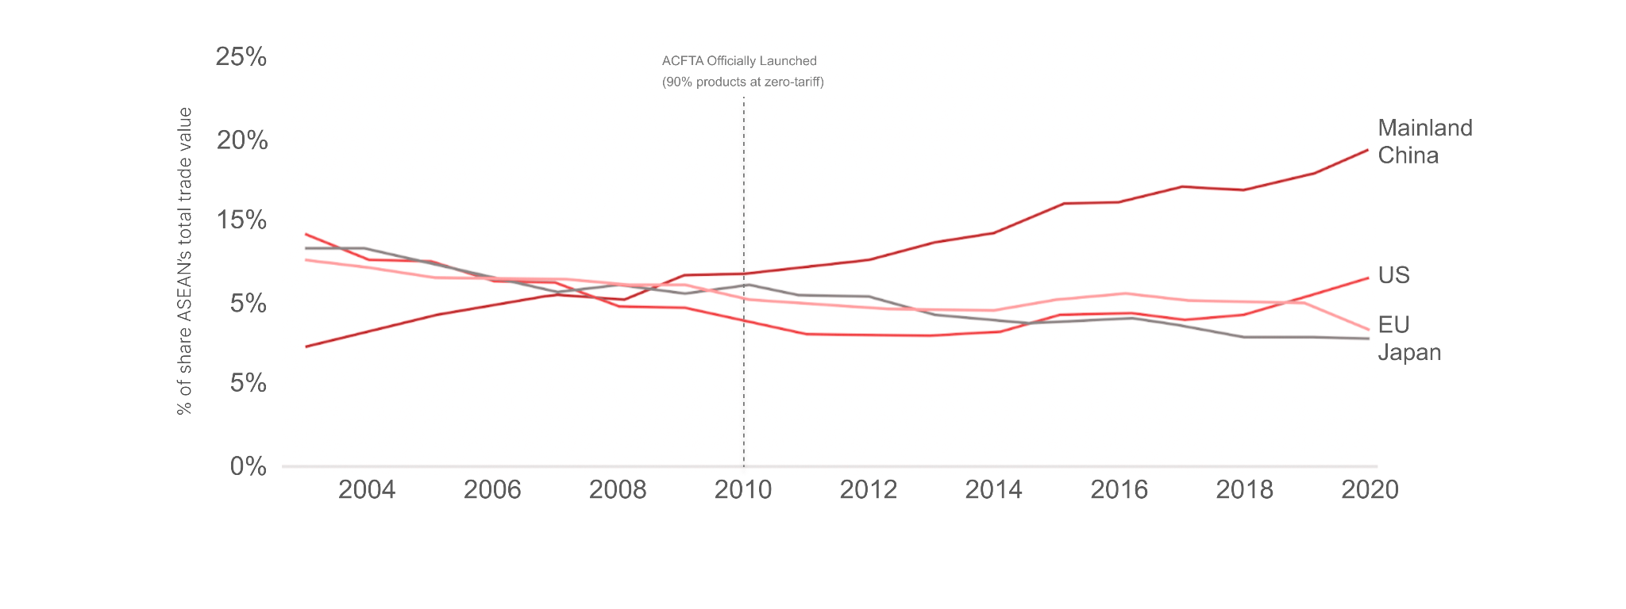
Figure 1.1 Trends in ASEAN-6 Trade Share by Major Trading Partners, 2000–2020
Source: ASEANstats (2022), processed by Author (2025).
This hypothesis of "carbon leakage" is supported by the contrasting environmental trend observed in ASEAN-6 nations. While China’s industrial emissions began to stabilize, the collective emissions of the ASEAN bloc have followed a sharp upward trend. Figure 1.2 below visualizes this divergence and shows a clear acceleration in production-based CO₂ emissions per capita in the ASEAN-6 region after the ACFTA implementation in 2010. This opposing trend suggests that the environmental gains in China may have been offset by environmental degradation in its regional partners. Previous studies in the Indonesian context, such as Puspita and Hartono (2021) as well as Azizurrohman and Hartarto (2019), have also indicated a positive correlation between trade openness and emissions. However, these studies often stop short of identifying the precise mechanism through which this pollution transfer occurs.
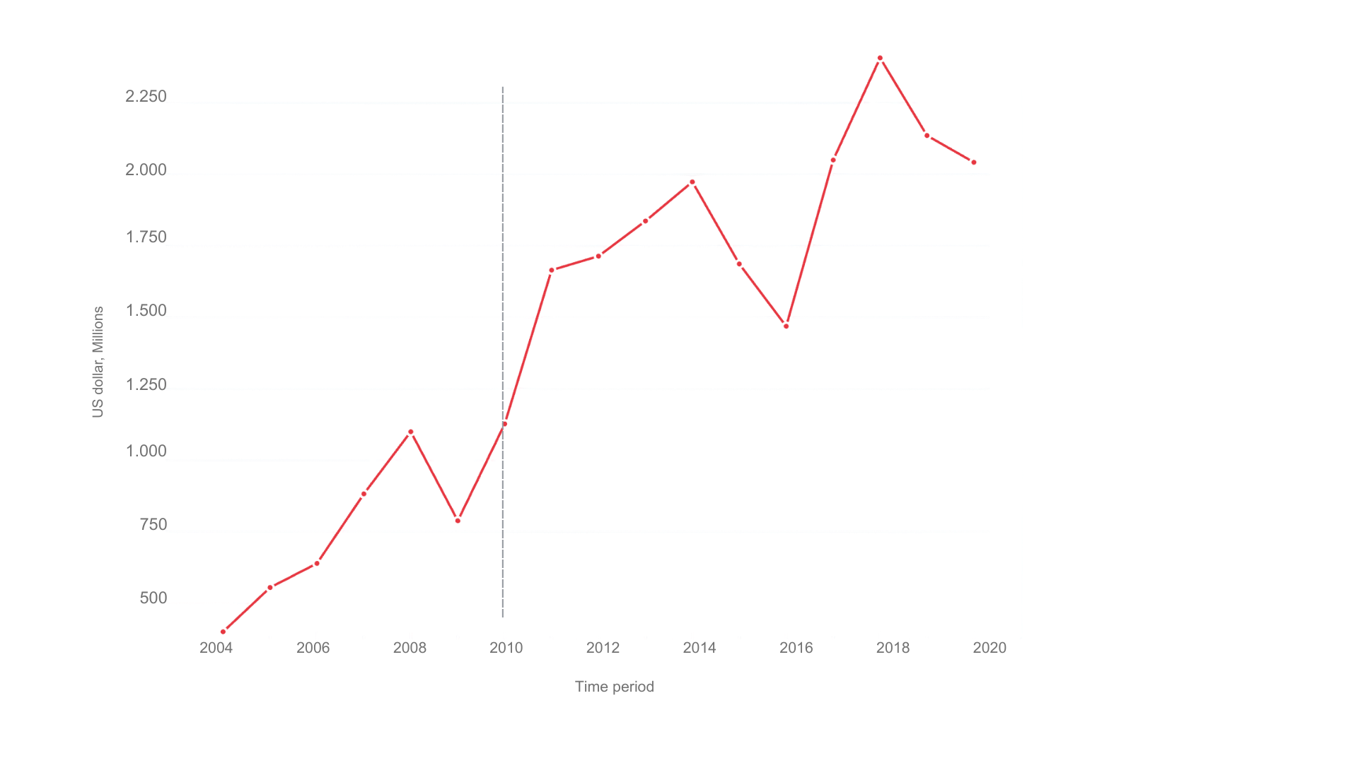
Figure 1.2 Comparison of Annual Production-based CO₂ Emissions per Capita: China and ASEAN-6, 2004–2020
Source: Global Carbon Project via Our World in Data (2024), processed by Author (2026).
The mechanism facilitating this suspected leakage is likely rooted in the deepening integration of Global Value Chains (GVCs). In this network, Indonesia has become more structurally dependent on China’s energy-intensive upstream production (e.g., intermediate chemicals and metals). This dependency suggests that the 'smokestack' of the supply chain might be shifting across borders.. This is quantitatively evidenced by the rising share of Chinese Foreign Value Added (FVA) embodied in Indonesia’s exports as shown in Figure 1.3 below.
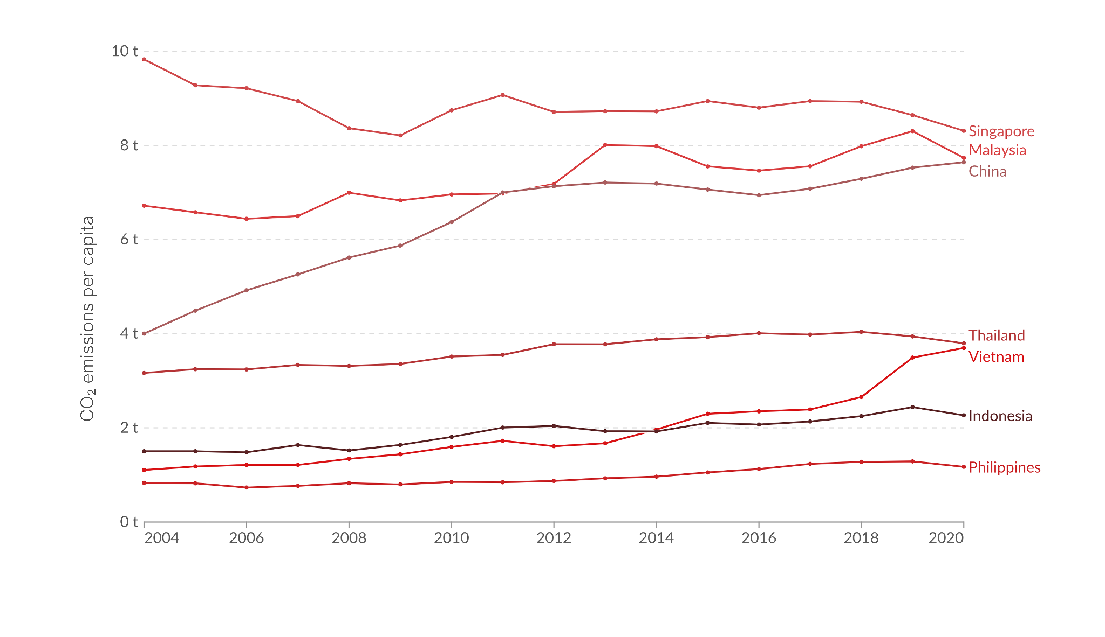
Figure 1.3 Chinese Foreign Value Added (FVA) Embodied in Indonesia’s Gross Manufacturing Exports, 2004–2020
Source: OECD TiVA Database (2025), processed by Author (2026).
This dependency manifests physically in the changing composition of bilateral trade. As depicted in Figure 1.4, the post-ACFTA period witnessed a significant surge in Indonesia’s imports of pollution-intensive intermediate goods from China, specifically chemicals and basic metals. While these facts present a compelling narrative consistent with the Pollution Haven Hypothesis, they primarily establish correlations based on aggregate trends. A rigorous causal link between ACFTA’s tariff reductions and the specific surge of pollution-intensive product flows into Indonesia has yet to be definitively established. This motivates the need for a more granular and product-level investigation following the approach of Cherniwchan (2017).
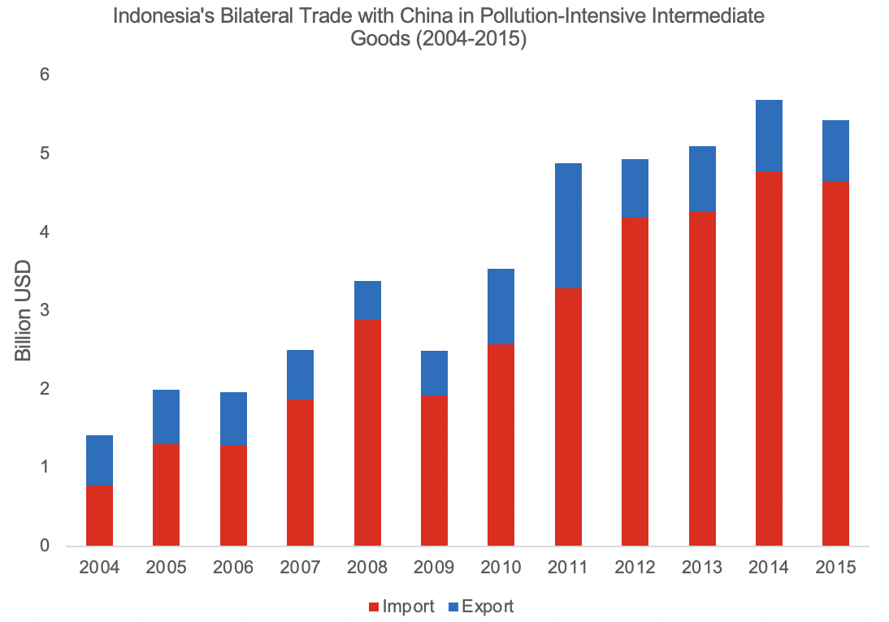
Figure 1.4 Indonesia’s Bilateral Trade with China in Pollution-Intensive Intermediate Goods, 2004–2015
Note: Pollution-intensive goods include Chemicals (HS 28, 29) & Basic Metals (HS 72, 73) based on the IPPS classification.
Source: UN Comtrade (2024), processed by Author (2026)
This massive structural deficit in carbon-intensive intermediate goods provides compelling prima facie evidence for the Pollution Haven mechanism. Yet, coincidence is not causality. Establishing a definitive causal link between ACFTA's tariff reductions and this surge in pollution-intensive imports requires a rigorous empirical strategy. Moving beyond aggregate macroeconomic trends to a disaggregated product-level validation is therefore essential to uncover the true environmental cost of Indonesia’s integration into the ASEAN-China production network (Cherniwchan, 2017).

Problem Statement & Research Gap
The central problem addressed in this thesis is the puzzling divergence in environmental trajectories between China and the ASEAN-6 nations following the full implementation of ACFTA. While China has successfully reduced its domestic carbon intensity as documented by Yi, Geng, and Yang (2023), the ASEAN bloc has concurrently experienced a sharp acceleration in CO2 emissions. This phenomenon raises the critical possibility of carbon leakage where the environmental gains in China are achieved not through genuine abatement, but by offshoring pollution-intensive production stages to its regional partners. Within this context, Indonesia stands as a potential epicenter for absorbing this relocated carbon footprint given its vast manufacturing base and the deepening of Global Value Chain integration. However, confirming whether this emission surge is truly a result of pollution haven seeking behavior rather than general economic expansion requires addressing three fundamental limitations in the existing literature.
The first major gap is the prevalence of aggregation bias in previous empirical studies. Research on the trade-environment nexus in ASEAN, such as the work by Azizurrohman and Hartarto (2019), predominantly relies on aggregate national-level data to estimate the impact of trade on emissions. This approach assumes that trade affects all sectors uniformly and inadvertently masks the composition effect described by Antweiler, Copeland, and Taylor (2001). By aggregating data at the national level, these studies fail to distinguish between the expansion of clean industries versus dirty industries. Consequently, they cannot empirically verify if the rise in emissions is driven by a structural shift toward pollution-intensive sectors, which is the core condition for the Pollution Haven Hypothesis. A robust analysis must therefore descend to the sectoral level to capture this heterogeneity.
The second limitation concerns the lack of empirical validation for the transmission mechanism. While existing literature acknowledges that Global Value Chains can facilitate pollution transfer, this mechanism remains treated as a black box. Studies typically establish a statistical correlation between aggregate trade or investment flows and emissions but fail to validate the physical manifestation of this relationship. If the Pollution Haven Hypothesis holds, the relocation of dirty industries should be visible not just in investment figures but in the cross-border movement of specific goods. Yet, no study has sufficiently utilized disaggregated product-level data to trace the surge of dirty capital goods and intermediate inputs from China to Indonesia. Without validating this physical flow of goods at the Harmonized System 6-digit level, arguments regarding carbon leakage remain speculative rather than definitive.
The third gap is methodological precision regarding the measurement of trade policy shocks. A substantial portion of the literature treats the ACFTA implementation as a single binary event by using dummy variables to compare pre-2010 and post-2010 periods. This binary approach ignores the reality that ACFTA tariff reductions were a gradual process phased out between 2005 and 2018. Treating trade liberalization as a one-time shock fails to capture the marginal impact of tariff changes on firm behavior and emissions. To address this, a Continuous Difference-in-Differences approach following Cherniwchan (2017) is required. This method utilizes the continuous variation in applied tariff rates to provide a more precise estimate of the elasticity of emissions to trade policy. By addressing these three gaps through a sequential macro-sectoral and micro-product analysis, this thesis aims to provide the first rigorous causal evidence of the pollution haven effect under the ACFTA regime.

Research Questions
- Does the trade liberalization under ACFTA exert a heterogeneous impact on carbon emissions in ASEAN-6 countries, specifically by inducing a structural shift towards pollution-intensive manufacturing sectors?
- Does the reduction of import tariffs under ACFTA induce a significant surge in the importation of pollution-intensive capital and intermediate goods from China to Indonesia compared to clean products?

Research Objectives
- To estimate and analyze the heterogeneous impact of ACFTA tariff reductions on carbon emissions between pollution-intensive and clean manufacturing sectors in ASEAN-6. By utilizing a Continuous Difference-in-Differences approach on regional panel data, this objective seeks to empirically test the existence of the composition effect predicted by the Pollution Haven Hypothesis.
- To validate the mechanism of industrial relocation by estimating the elasticity of import volumes to tariff changes for pollution-intensive products in Indonesia. Using disaggregated product-level data, this objective aims to provide micro-level evidence that trade liberalization has specifically incentivized the sourcing of "dirty" inputs, thereby validating the physical channel of carbon leakage.

CHAPTER 2
LITERATURE REVIEW

Trade and Environment Theory
The theoretical nexus between international trade and environmental quality is fundamentally rooted in the classical Heckscher-Ohlin (H-O) trade model, which posits that a country's comparative advantage is determined by its relative abundance of production factors (Ohlin, 1933). While the original framework focused on capital and labor endowments, subsequent scholarship extended this model by conceptualizing the environment, specifically, its assimilative capacity for pollution as a distinct factor of production (Copeland & Taylor, 2004). This conceptual leap allows environmental regulation to be treated as a determinant of factor prices: stringent regulations essentially make the "use of the environment" expensive, while lax regulations make it cheap. Consequently, trade liberalization influences environmental outcomes not merely through increased volume, but through the reallocation of production activities based on these factor price differentials.
This extension of the H-O framework gives rise to two competing hypotheses regarding the direction of trade in pollution-intensive goods: the Factor Endowment Hypothesis (FEH) and the Pollution Haven Hypothesis (PHH). The FEH maintains that traditional factor endowments remain the primary drivers of comparative advantage. Since pollution-intensive industries (such as chemicals, steel, and cement) are typically capital-intensive, the FEH predicts that capital-abundant developed countries will retain a comparative advantage in these sectors, despite their stricter environmental regulations (Antweiler et al., 2001; Cole & Elliott, 2003). Under this hypothesis, trade liberalization would lead to a concentration of dirty industries in the developed "North," potentially improving environmental quality in the labor-abundant developing "South."
Conversely, the Pollution Haven Hypothesis challenges this view by asserting that disparities in environmental policy stringency can override traditional factor endowments. Copeland and Taylor (1994) formalized this mechanism in a North-South trade model, demonstrating that if income-induced differences in environmental regulation are sufficiently large, they become the decisive source of comparative advantage. In this scenario, developing countries with lower income levels and consequently laxer environmental standards offer a "regulatory subsidy" to pollution-intensive firms. Trade liberalization thus incentivizes the relocation of dirty industries from the strictly regulated North to the developing South, transforming the latter into a "pollution haven."
The empirical validity of these hypotheses is often context-dependent, determined by the interplay between a country's capital abundance and its regulatory stringency. Cole and Elliott (2003) emphasize that these two forces often work in opposite directions: capital abundance pulls dirty industries toward developed nations, while regulatory costs push them away. In the specific context of ACFTA, the traditional North-South dichotomy warrants reinterpretation. While both China and ASEAN are developing economies, China’s recent aggressive environmental reforms (Yi et al., 2023) have created a regulatory divergence akin to the North-South model. China now acts as the regulatorily stricter 'North,' pushing pollution-intensive capacities toward the relatively laxer ASEAN-6 ('South'). This unique dynamic creates a fertile ground for testing the Pollution Haven Hypothesis within a South-South integration framework.

The Environmental Kuznets Curve
A rigorous analysis of the trade-environment nexus necessitates accounting for the independent, non-linear relationship between economic growth and environmental quality. This relationship is formalized in the Environmental Kuznets Curve (EKC) hypothesis, first empirically documented by Grossman and Krueger (1991, 1995) in their seminal assessment of the North American Free Trade Agreement (NAFTA). The EKC posits an inverted U-shaped trajectory between per capita income and environmental degradation: pollution levels initially rise as a country develops, but eventually decline once a certain income threshold is surpassed (Grossman & Krueger, 1995; Copeland & Taylor, 2004). This hypothesis suggests that economic growth is not inherently detrimental to the environment in the long run, provided that the structural transformation of the economy allows for cleaner production methods to emerge.
The theoretical mechanism driving the EKC is typically decomposed into three concurrent forces: scale, composition, and technique effects. In the early stages of industrialization, the scale effect dominates, where the sheer expansion of economic activity leads to increased resource extraction and energy consumption, resulting in higher emissions (Antweiler et al., 2001). As an economy matures and income levels rise, two countervailing forces gain momentum. First, public demand for environmental quality increases, prompting stricter regulations and incentivizing investment in cleaner technologies, a phenomenon known as the technique effect. Second, the composition effect may shift the economic structure from pollution-intensive heavy industries toward cleaner service-based sectors. The EKC’s turning point materializes when the pollution-reducing impacts of the technique and composition effects begin to outweigh the pollution-increasing impact of the scale effect (Dean, 2002; Cole & Elliott, 2003).
However, the empirical validity of the EKC is not universal, particularly for global pollutants such as carbon dioxide ($CO_{2}$). Unlike local pollutants where abatement yields immediate domestic health benefits, $CO_{2}$ abatement provides a global public good. For developing ASEAN economies focused on rapid industrialization, the incentive to unilaterally abate CO₂ is diminished by the free-rider problem, causing the scale effect to persistently dominate the technique effect long after middle-income status is reached. Foundational studies, including Grossman and Krueger (1995), have noted that while an EKC relationship is often robust for local air and water pollutants, $CO_{2}$ emissions tend to rise monotonically with income or exhibit a turning point at income levels far beyond what most developing countries can achieve in the near term. This evidence suggests that for $CO_{2}$ in developing economies, the scale effect of growth consistently overwhelms any nascent technique effect, keeping these nations on the upward-sloping portion of the curve.
Acknowledging this critical caveat, this thesis does not aim to test the validity of the EKC hypothesis for $CO_{2}$ as its central premise. Instead, it employs the EKC’s quadratic specification of per capita income as a necessary control framework to account for the technique effect driven by endogenous economic growth. By controlling for this underlying, income-driven environmental trajectory, the econometric model can more accurately isolate the marginal impact of the exogenous trade policy shock from ACFTA. The primary investigation thus shifts to determining whether the trade-induced composition effect, specifically the potential relocation of dirty industries as predicted by the Pollution Haven Hypothesis, it is powerful enough to disrupt the long-term environmental path that the EKC framework is designed to capture.

The Transmission Mechanism
To disentangle the complex relationship between trade liberalization and environmental outcomes, the literature has widely adopted the decomposition framework pioneered by Antweiler, Copeland, and Taylor (2001). This framework provides a rigorous basis for analyzing how a trade policy shock, such as the tariff reductions under ACFTA, transmits through an economy to alter its environmental trajectory. As illustrated in Figure 2.3, the net impact of trade is determined by the interplay of three distinct and often opposing channels: the scale effect, the technique effect, and the composition effect (Grossman & Krueger, 1993; Copeland & Taylor, 2004).
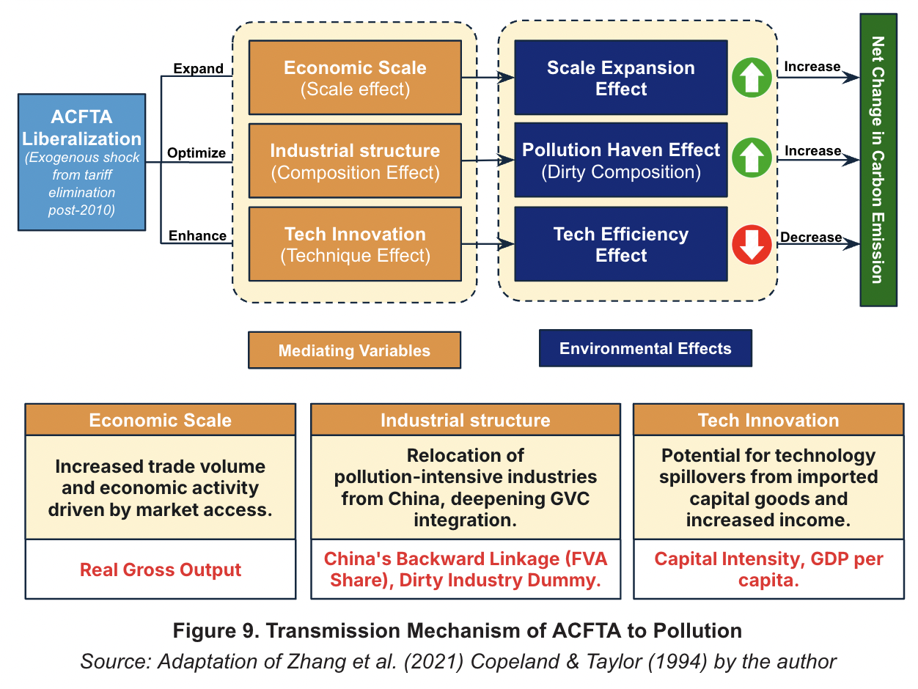
Figure 2.3. Transmission Mechanism of ACFTA to Pollution
(Source: Adaptation of Zhang et al. (2021) Copeland & Taylor (1994) by the author)
The scale effect represents the most direct consequence of trade expansion. By reducing trade costs and expanding market access, agreements like ACFTA stimulate economic activity and increase the overall volume of production and consumption. Ceteris paribus, holding technology and industrial composition constant, this expansion requires greater energy consumption and material inputs, thereby generating a proportional increase in pollution emissions (Antweiler et al., 2001). Thus, the scale effect is generally detrimental to environmental quality, reflecting the environmental cost of the additional economic growth fostered by trade.
In contrast, the technique effect captures the pollution-reducing potential of trade-induced income growth. As trade liberalization raises real incomes, it triggers two mechanisms that can lower emission intensity. First, public demand for environmental quality, considered a normal good, typically rises with income, leading to more stringent government regulations (Copeland & Taylor, 2004). Second, increased competition and access to foreign markets facilitate the transfer of cleaner technologies and managerial practices, often embodied in foreign direct investment (FDI) or imported capital goods. This effect suggests that as countries become wealthier and more integrated into the global economy, the pollution emitted per unit of output should decline (Cole & Elliott, 2003).
The ultimate sign and magnitude of trade's environmental impact, however, are frequently determined by the composition effect. This effect describes the change in a country's industrial structure as it specializes in sectors where it holds a comparative advantage. The environmental outcome of this structural shift hinges on the source of that comparative advantage. In a North-South trade context like ACFTA, the Pollution Haven Hypothesis posits that comparative advantage is driven by international differences in environmental policy stringency rather than just factor endowments. If developing ASEAN nations leverage laxer regulations to attract investment, trade liberalization will induce a composition effect that shifts their industrial base toward pollution-intensive sectors (Copeland & Taylor, 1994). Consequently, while the technique effect may lower emissions per unit, a strong composition effect toward "dirty" industries can overwhelm these gains, leading to a net increase in total emissions.
These theoretical effects do not occur in a vacuum but materialize through the fragmentation (unbundling) of Global Value Chains (GVCs). This fragmentation allows firms to separate clean production stages from dirty ones. The composition effect in this study is explicitly defined as the relocation of these specific pollution-intensive production stages, embodied in intermediate inputs and capital goods, from China to ASEAN. Chinese multinational enterprises may engage in vertical FDI to arbitrage regulatory costs, increasing China’s Foreign Value Added (FVA) in ASEAN's dirty sectors (Li, Scollay, & Maani, 2016). Simultaneously, ASEAN firms deepen their GVC integration by surging their imports of "dirty" intermediate inputs (e.g., chemicals, basic metals). As depicted in the "Mediating Variables" section of Figure 2.3, these specific investment and trade channels serve as the physical transmission mechanism for the Pollution Haven effect, validating the suspicion of carbon leakage (Meng et al., 2018).

Review of Empirical Studies
The empirical landscape regarding the trade-environment nexus is characterized by a compelling, yet incomplete, narrative. A synthesis of recent literature reveals a striking dichotomy in the environmental outcomes of trade liberalization between developed and developing economies. On one hand, evidence from the "North" suggests that trade can facilitate decarbonization. Yi, Geng, and Yang (2023), in a quasi-experimental study of the ACFTA, find that trade openness has significantly reduced carbon emission intensity within China. They attribute this to strong technique effects and the structural upgrading of Chinese industries. However, this finding immediately poses a critical question of attribution: does this reduction represent a genuine global elimination of emissions, or merely a relocation of pollution-intensive production stages to trading partners?
The literature on Global Value Chains (GVCs) provides a plausible mechanism for such relocation. Qian et al. (2022) demonstrate that for RCEP countries, deeper integration into GVCs—specifically through backward linkages—is positively associated with increased carbon emissions. This suggests that as developing nations import more intermediate inputs to participate in global production networks, they may be inadvertently importing the embodied carbon of upstream production stages. While Qian et al. (2022) establish the correlation between GVC participation and emissions, their aggregate analysis treats the specific channels of this transfer as a "black box," failing to identify which specific industries or products drive this relationship.
This limitation is further compounded by the issue of aggregation bias prevalent in many studies. Early empirical tests of the Pollution Haven Hypothesis often utilized national-level data, which masks the heterogeneous impact of trade across sectors. Cole and Elliott (2003) addressed this by employing interaction terms to distinguish between capital-intensive and labor-intensive sectors, finding that the composition effect of trade is indeed pollution-increasing for countries with lax regulations. However, their study, like many others, stops at the sectoral level. To definitively prove that trade liberalization causes pollution transfer, one must observe the physical flow of pollution-intensive goods. Cherniwchan (2017) pioneered a methodological breakthrough in this regard by utilizing disaggregated product-level data to analyze the impact of NAFTA. He found that tariff reductions led to a disproportionate increase in the imports of dirty goods into the United States, providing granular evidence of the composition effect that aggregate studies miss.
Despite these advancements, a significant gap remains in the context of Southeast Asia. Current literature on the environmental impact of ACFTA predominantly relies on aggregate data and often models the trade agreement as a simple binary shock (pre- and post-2010). This binary approach ignores the gradual tariff phase-outs, introducing measurement error in the treatment variable. Consequently, estimates derived from binary shocks likely suffer from attenuation bias, underestimating the true elasticity of emissions to trade policy. By adopting a Continuous DiD approach, this thesis aims to fill these gaps by adopting a sequential identification strategy that synthesizes the sectoral heterogeneity approach of Cole and Elliott (2003) with the rigorous product-level identification of Cherniwchan (2017), thereby providing a comprehensive empirical test of the pollution haven effect in the ACFTA era.

Conceptual Framework and Hypotheses
Building upon the theoretical foundations of the trade-environment nexus, this section synthesizes the discussed literature into a cohesive conceptual framework that maps the causal pathway from trade liberalization to environmental outcomes. This framework, visualized in Figure 2.1, outlines the logical progression of the study, moving from the initial policy shock through the mediating mechanisms and theoretical decomposition to the specific, testable hypotheses that guide the empirical analysis.
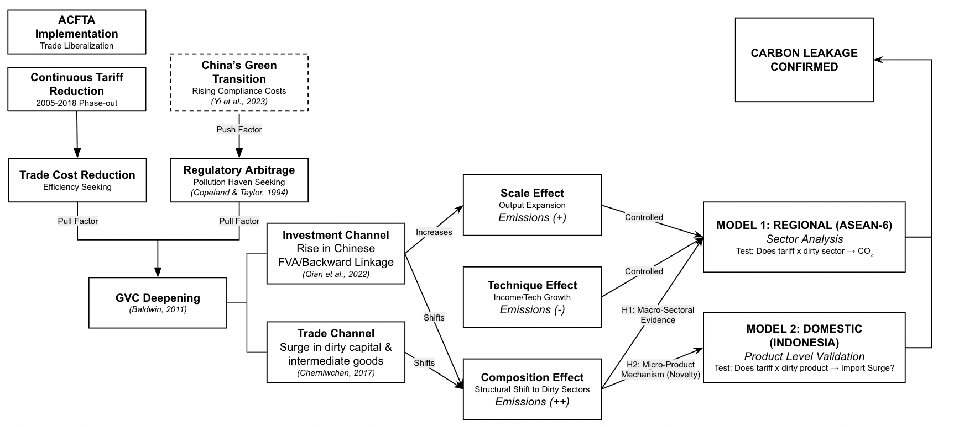
Figure 2.5: Conceptual Framework Diagram
(Source: Author, 2026)
The framework begins with two concurrent external stimuli. The primary stimulus is the ACFTA implementation, characterized by a continuous and phased reduction of tariffs from 2005 to 2018. This reduction in trade barriers serves as a direct "pull factor," lowering the costs of cross-border trade and incentivizing deeper economic integration. Simultaneously, China's domestic "Green Transition" acts as a complementary "push factor." As documented by Yi, Geng, and Yang (2023), rising environmental compliance costs within China motivate its firms to seek production locations with more lenient regulatory environments.
These dual forces converge on a central mechanism: Global Value Chain (GVC) deepening, facilitated by regulatory arbitrage. The pursuit of lower compliance costs, as theorized in the Pollution Haven Hypothesis (Copeland & Taylor, 1994), combined with the efficiency gains from lower tariffs, accelerates the fragmentation of production across the region. This GVC integration manifests through two distinct channels: (1) an investment channel, characterized by a rise in Chinese foreign value-added (FVA) embodied in ASEAN exports (Qian et al., 2022), and (2) a trade channel, marked by a surge in the trade of intermediate and capital goods (Cherniwchan, 2017). These GVC channels correspond to the decomposition framework of Antweiler, Copeland, and Taylor (2001). While scale and technique effects operate concurrently, the core of this study focuses on the Composition Effect: the structural shift in ASEAN economies toward pollution-intensive sectors. This causal chain leads to a two-tiered empirical strategy: a macro-sectoral analysis (Model 1) and a micro-product validation (Model 2).

2.5.1. Hypothesis Development
1. Macro-Sectoral Composition Effect
The core prediction of the Pollution Haven Hypothesis suggests that trade liberalization will induce a structural shift in developing countries towards "dirty" industries. In the context of ACFTA, the reduction of tariffs reduces the cost of importing intermediate inputs and capital goods required for pollution-intensive production. Consequently, sectors with high pollution intensity in ASEAN-6 are expected to expand more rapidly than clean sectors due to the relocation of production activities from China. Theoretically, this implies that the composition effect toward dirty industries will outweigh any technique effect gains in these sectors (Cole & Elliott, 2003). Therefore, the first hypothesis is proposed:
H1: The reduction of tariffs under ACFTA leads to a disproportionate increase in carbon emission intensity within pollution-intensive manufacturing sectors compared to clean sectors across ASEAN-6 countries.
2. Micro-Product Mechanism Validation
To validate the physical transmission mechanism of carbon leakage, it is necessary to examine the flow of goods that facilitates the structural shift identified in H1. If the composition effect is driven by the relocation of production stages, this should be observable in the trade data as a surge in the importation of specific inputs used in dirty industries (e.g., chemicals, basic metals, machinery). Following Cherniwchan (2017), a significant increase in imports of these "dirty" inputs relative to clean goods would confirm that domestic production is increasingly fueled by pollution-intensive inputs sourced from China. Based on this, the second hypothesis is formulated:
H2: The tariff liberalization under ACFTA induces a significant surge in the import volume of pollution-intensive intermediate and capital goods from China into Indonesia, relative to clean products.

CHAPTER 3
RESEARCH METHODOLOGY

Data set and Unit of Analysis
To empirically investigate the environmental consequences of the ASEAN-China Free Trade Area (ACFTA), this study employs a sequential identification strategy that relies on two distinct but complementary panel datasets. The empirical framework is designed to first capture the macro-sectoral composition effects across the region and subsequently validate the physical transmission mechanism at the micro-product level in Indonesia. Consequently, the data construction is divided into a regional-sectoral dataset for Model 1 and a domestic-product dataset for Model 2. Data are sourced from several authoritative international databases, including the Organisation for Economic Co-operation and Development (OECD), the United Nations (UN), and the World Bank.

3.1.1. Regional-Sectoral Data (Model 1)
The first stage of the analysis utilizes a multidimensional panel dataset structured at the country-sector-year level. The spatial domain encompasses six major ASEAN economies: Indonesia, Malaysia, the Philippines, Singapore, Thailand, and Vietnam. The sectoral domain covers 16 manufacturing industries classified under the International Standard Industrial Classification (ISIC) Revision 4. The temporal scope spans from 2005 to 2018, capturing the periods before, during, and after the full implementation of the ACFTA tariff elimination in 2010.
Data for this regional analysis are compiled from three primary sources. Production-based carbon dioxide emissions and the Global Value Chain backward linkage metric (measured as Chinese foreign value-added embodied in ASEAN exports) are extracted from the OECD Trade in Value Added (TiVA) database. Utilizing emissions and value-added data from the exact same MRIO (Multi-Regional Input-Output) framework is crucial to avoid sectoral mismatch and aggregation errors. Since the OECD TiVA database is published at varying intervals, missing intermediate years within the 2005 to 2018 timeframe are estimated using a linear interpolation technique, following the established methodological precedent in global value chain literature by Qian et al. (2022).
Macroeconomic control variables, including real GDP per capita, trade openness, and manufacturing value-added shares, are sourced from the World Bank’s World Development Indicators (WDI). Furthermore, the primary treatment variable, the applied tariff rate, is obtained from the World Bank's World Integrated Trade Solution (WITS). To construct the sectoral tariff variable without introducing endogeneity from fluctuating annual trade volumes, the highly disaggregated product-level tariffs are aggregated into the 16 ISIC sectors using fixed import weights from the base year of 2005.

3.1.2. Domestic-Product Data (Model 2)
The second stage of the analysis narrows the geographic focus to Indonesia to validate the physical relocation of pollution-intensive production. This stage employs a highly disaggregated product-year panel dataset focusing exclusively on Indonesia's bilateral imports from China. The unit of observation is at the 6-digit level of the Harmonized System (HS) nomenclature. To cleanly capture the immediate trade behavioral response surrounding the ACFTA policy shock, the time horizon for this micro-level validation is symmetrically narrowed to an 11-year window from 2005 to 2015.
The dependent variable, bilateral import value, along with the data for China's total global export supply, is sourced from the UN Comtrade database. The applied Most-Favored-Nation (MFN) tariff rates are again retrieved from WITS. Constructing a valid causal design at this granular level requires two critical data engineering procedures. First, to ensure that the analysis strictly captures industrial relocation rather than shifts in retail consumption, the product-level data is rigorously filtered using the UN Broad Economic Categories (BEC). The sample is restricted entirely to capital goods and intermediate inputs. Consumption goods, particularly food and beverage products (BEC codes 112 and 122), are deliberately excluded. As highlighted by Copeland and Taylor (2004), the Pollution Haven Hypothesis is driven by industrial pollution abatement costs, making heavy manufacturing inputs the only theoretically valid subjects for this mechanism.
Second, international trade databases suffer from temporal inconsistencies due to periodic revisions of the HS nomenclature. To prevent spurious discontinuities or artificial breaks in the trade time series, all HS-6 product codes across the 2005 to 2015 period are harmonized and anchored to the HS 2007 Revision. This harmonization is executed using the official concordance tables provided by the United Nations Statistics Division. This rigorous standardization ensures that the estimated tariff elasticities reflect genuine changes in physical trade flows rather than artifacts of administrative code reclassification.

Variable Estimation and Operationalization
Table 3.2. provides a comprehensive summary of all variables employed in both the regional-sectoral analysis (Model 1) and the domestic product-level validation (Model 2), outlining their respective roles, operationalization, and data sources.
Table 3.2 Summary of Variables
Variable Name | Role in Model | Measurement/ Operationalization | Data Source
Model 1: Regional-Sectoral Analysis (ASEAN-6)
${Ln(CO2}_{ijt})$ | Dependent | Natural log of production-based CO₂ emissions per sector. | OECD TiVA
${Ln(1+Tariff}_{ijt-1})$ | Main Treatment | Natural log of applied tariff rates, aggregated using fixed 2005 base-year import weights. | WITS
${Dirty_{Dummy}}_{i}$ | Moderator | Binary indicator: 1 if Pollution Abatement Cost (PAC) ratio > median, 0 otherwise. | IPPS (Hettige et al., 1995)
$[Ln(1+Tariff)×Dirty]$ | DiD Interaction | Interaction between the continuous tariff treatment and the dirty sector dummy. | Constructed
$Ln(GVC_{BL_{ijt-1}})$ | Mediator / Control | Natural log of Chinese Foreign Value-Added (FVA) embodied in gross exports. | OECD TiVA
$Ln(GDPpc_{jt-1})$ | Control | Natural log of real GDP per capita (constant 2017 USD PPP), lagged by one year. | World Bank WDI
$[Ln(GDPpc_{jt-1})]^{2}$ | Control | The squared term of the natural log of real GDP per capita. | World Bank WDI
$Openness_{jt-1}$ | Control | Total trade (exports plus imports) as a percentage of GDP. | World Bank WDI
$Urban_{jt-1}$ | Control | Urban population as a percentage of total population. | World Bank WDI
$MfgShare_{jt-1}$ | Control | Manufacturing value-added as a percentage of GDP. | World Bank WDI
Model 2: Regional-Sectoral Analysis (ASEAN-6)
$Ln(Import_{pt})$ | Dependent | Natural log of bilateral import value from China to Indonesia (FOB). | UN Comtrade
$Ln(1+Tariff_{p,t-1})$ | Main Treatment | Natural log of applied MFN tariff rate per HS-6 product. | WITS
$Dirty_{Dummy_{p}}$ | Moderator | Binary indicator mapped from ISIC to HS-6: 1 if dirty, 0 if clean. | IPPS Concordance
$[Ln(1+Tariff)×Dirty]$ | DiD Interaction | Interaction between the product-level tariff and the dirty product dummy. | Constructed
$Ln(ChinaSupply_{p,t-1})$ | Control | Natural log of China’s total global exports for product p, excluding exports to Indonesia. | UN Comtrade
$Ln(ExRate_{t-1})$ | Control | Natural log of the bilateral exchange rate (IDR/CNY). | IMF IFS
(Source : Author’s illustration, 2026)

3.2.1. Dependent Variables
The dependent variable for the macro-regional analysis (Model 1) is the natural logarithm of production-based carbon dioxide emissions, denoted as ${Ln(CO2}_{ijt})$. This variable measures the absolute volume of emissions generated by specific manufacturing sectors within the ASEAN-6 countries. For the micro-domestic validation (Model 2), the dependent variable is the natural logarithm of the bilateral import value from China to Indonesia at the HS-6 digit product level, denoted as $Ln(Import_{pt})$. In both models, the logarithmic transformation is applied to mitigate the right-skewness typical of emissions and trade flow data, ensuring a more normal distribution while allowing the resulting estimated coefficients to be interpreted as elasticities.

3.2.2. Variables of Interest
To capture the gradual nature of the ACFTA liberalization, the primary treatment variable is defined continuously as the natural logarithm of the applied tariff rate, expressed as $Ln(1+Tariff_{ijt-1})$ for the regional analysis and $Ln(1+Tariff_{pt-1})$ for the product level validation.
The addition of the constant one is a necessary mathematical adjustment to accommodate zero tariff rates, which naturally occur in the post-ACFTA period, without dropping observations during the logarithmic transformation. Furthermore, the tariff variable is lagged by one year to ensure strict time-precedence, thereby avoiding simultaneity bias and properly accounting for the delayed behavioral adjustments of firms reconfiguring their supply chains in response to trade policy shocks.
To distinguish between the environmental impacts across different types of industries, a time-invariant moderator variable, the $Dirty_{dummy}$ is introduced. This classification relies on the Industrial Pollution Projection System (IPPS) developed by the World Bank (Hettige et al., 1995). Following standard environmental economics literature, an industry or product is coded as 1 (dirty) if its Pollution Abatement Cost (PAC) ratio falls above the median of the manufacturing sector, and 0 (clean) otherwise. The central parameter of interest is the interaction term between the lagged continuous tariff and time-invariant $Dirty_{dummy}$ , denoted as $[Ln(1+Tariff_{ijt-1})×Dirty_{i}]$ and $[Ln(1+Tariff_{pt-1})×Dirty_{p}]$ respectively. This interaction explicitly captures the composition effect, allowing the model to test the core premise of the Pollution Haven Hypothesis by identifying whether tariff reductions induce a disproportionately larger surge in emissions and imports within highly polluting sectors compared to their cleaner counterparts.

3.2.3. Control Variables
In the regional-sectoral analysis (Model 1), the model incorporates a rigorous set of macroeconomic and structural controls. To account for the technique effect and the non-linear relationship between income and environmental quality, the natural logarithm of real GDP per capita and its squared term are included, effectively embedding the Environmental Kuznets Curve (EKC) framework into the baseline estimation. Additionally, the Global Value Chain backward linkage metric—measured as the share of Chinese foreign value-added embodied in ASEAN exports—is utilized as a mediating proxy to capture the region's structural reliance on Chinese industrial inputs and investments. The model further controls for general scale effects and macroeconomic transformations by including aggregate trade openness, the urbanization rate, and the manufacturing sector’s share of total value-added. All control variables are lagged by one period to prevent endogeneity.
For the product-level validation (Model 2), the control variables are tailored to address trade-specific confounders. To ensure that an observed surge in Indonesian imports is driven by ACFTA tariff reductions rather than an overall increase in Chinese manufacturing dominance, the model controls for China’s global export supply capacity. Following the methodological precedent set by Autor, Dorn, and Hanson (2013), this is measured as the natural logarithm of China’s total worldwide exports of a given product, explicitly excluding exports destined for Indonesia. Finally, the natural logarithm of the bilateral exchange rate is included to control for macroeconomic purchasing power and currency fluctuations that mechanically influence cross-border trade volumes independent of tariff policies.

Empirical Strategy and Econometrical Model
The empirical strategy of this research relies on a Continuous Difference-in-Differences approach estimated through a Two-Way Fixed Effects model. This overarching framework is specifically chosen to exploit the continuous variation in tariff reductions over time and across varying industries. By utilizing a continuous treatment variable, the model accurately captures the marginal elasticity of environmental and trade outcomes in response to the gradual phase-out of ACFTA tariffs, avoiding the oversimplifications inherent in traditional binary pre-post designs.

Model 1: Regional Sectoral Analysis
To empirically quantify the macro-sectoral composition effect and isolate the specific role of Global Value Chain integration, this study employs a stepwise mediation approach. The first step estimates the total effect of tariff liberalization on carbon emissions without controlling for the mediation channel. This baseline total effect is specified in Equation 1A:
$ln(CO2_{ijt})=α+β_{1}ln(1+Tariff_{ijt-1})+β_{2}[ln(1+Tariff_{ijt-1})×Dirty_{i}]+TZ_{jt-1}+δ_{i}+μ_{t}+ϵ_{ijt}$
In this specification, the parameter $β_{2}$ captures the total heterogeneous impact of tariff reductions on pollution-intensive sectors relative to clean sectors. To establish the composition effect predicted by the Pollution Haven Hypothesis, the expected signs for both $β_{1}$ and $β_{2}$ are negative. A negative coefficient mathematically indicates an inverse relationship where a reduction in tariffs leads to an increase in carbon emissions. Specifically, a significantly negative $β_{2}$ implies that trade liberalization disproportionately accelerates emission growth in dirty industries, confirming a structural shift toward pollution-intensive production. The vector $Z_{jt-1}$ represents the set of lagged macroeconomic controls, while $δ_{i}$ and $μ_{t}$ capture sector and year fixed effects, respectively.
The second step introduces the mediating variable to estimate the direct effect of tariffs after accounting for the Global Value Chain channel, as specified in Equation 1B:
$ln(CO2_{ijt})=α+β_{1}^{*}ln(1+Tariff_{ijt-1})+β_{2}^{*}[ln(1+Tariff_{ijt-1})×Dirty_{i}]+β_{3ln}(GVC_{BL_{ijt-1}})+TZ_{jt-1}+δ_{i}+μ_{t}+ϵ_{ijt}$
By comparing the interaction coefficients between Equation 1A and Equation 1B, the study can ascertain whether the Chinese backward linkage metric acts as a significant mediator for the pollution transfer. To address potential heteroskedasticity and arbitrary within-group correlation of the error terms across time, standard errors in both specifications are clustered at the country level, following the standard econometric practices recommended by Cameron and Miller (2015).

Model 2: Domestic Product Validation
To validate the physical transmission mechanism at the micro level, the second model shifts the focus to Indonesia's bilateral imports from China. This product-level Continuous Difference-in-Differences framework is specified in Equation 2:
$ln(Import_{pt})=α+γ_{1}ln(1+Tariff_{p,t-1})+γ_{2}[ln(1+Tariff_{p,t-1})×Dirty_{p}]+γ_{3}ln(ChinaSupply_{pt-1})+γ_{4}ln(ExRate_{t-1})+δ_{p}+μ_{t}+ϵ_{pt}$
The primary parameter of interest in this validation model is $γ_{2}$. Consistent with the macro-level expectations, the theoretical expectation for γ2 is strictly negative. A negative and statistically significant coefficient would confirm that reductions in product-level tariffs causally induced a larger and disproportionate surge in the importation of dirty intermediate and capital goods from China compared to clean goods. This specification controls for product fixed effects ($δ_{p}$) to absorb time-invariant product characteristics and year fixed effects ${(μ}_{t})$ to account for global macroeconomic shocks. Furthermore, to account for serial correlation within specific product lines over the 11-year panel, standard errors are clustered at the HS-6 product level.

3.4. Identification Assumptions and Robustness Checks

3.4.1. Parallel Trends Assumption
The fundamental identifying assumption of any Difference-in-Differences design is the parallel trends assumption. This assumption dictates that in the absence of the ACFTA tariff reductions, the emission trajectories and import volumes of the pollution-intensive treatment group would have evolved in parallel with the clean control group. To rigorously and formally test the validity of this assumption, the study will implement an Event Study framework. By introducing leads and lags of the continuous treatment variable into the baseline specification, this approach will visually and statistically verify the absence of diverging pre-existing trends in the years leading up to the full implementation of ACFTA in 2010.

3.4.2. Robustness Strategies
To ensure the reliability and stability of the baseline estimates, the study outlines two primary robustness strategies. First, an outlier sensitivity analysis will be conducted on Model 1 by completely excluding Singapore from the regional dataset, thereby yielding a restricted ASEAN-5 sample. Given Singapore's unique structural position as a highly developed and service-oriented entrepot with minimal heavy manufacturing activities, its inclusion might skew the regional average and dilute the observed composition effect. Re-estimating the model without Singapore ensures that the findings are genuinely representative of the developing ASEAN economies and are not driven by a single structural outlier.
Second, the study addresses potential econometric biases arising from the logarithmic transformation of zero trade flows in the highly disaggregated product-level data of Model 2. Because the natural logarithm of zero is undefined, ordinary least squares estimation often drops these observations, which can lead to sample selection bias. To correct for this, the study will utilize the Poisson Pseudo-Maximum Likelihood estimator as a robustness check. This estimator naturally accommodates zero trade values and produces consistent estimates in the presence of heteroskedasticity, ensuring that the micro-level validation remains highly robust to the choice of functional form.

REFERENCES

Antweiler, W., Copeland, B. R., & Taylor, M. S. (2001). Is free trade good for the environment? The American Economic Review, 91(4), 877–908. https://doi.org/10.1257/aer.91.4.877

Autor, D. H., Dorn, D., & Hanson, G. H. (2013). The China syndrome: Local labor market effects of import competition in the United States. The American Economic Review, 103(6), 2121–2168. https://doi.org/10.1257/aer.103.6.2121

Azizurrohman, M., & Hartarto, R. B. (2019). Trade and environment in Indonesia: Case study of ASEAN-China Free Trade Agreement. Jurnal Ekonomi dan Studi Pembangunan, 20(1), 81–95. https://doi.org/10.18196/jesp.20.1.5010

Baldwin, R. (2011). Trade and industrialisation after globalisation's 2nd unbundling: How building and joining a supply chain are different and why it matters (NBER Working Paper No. 17716). National Bureau of Economic Research. https://doi.org/10.3386/w17716

Cameron, A. C., & Miller, D. L. (2015). A practitioner’s guide to cluster-robust inference. Journal of Human Resources, 50(2), 317–372. https://doi.org/10.3368/jhr.50.2.317

Chen, J., Long, X., & Lin, S. (2022). Special economic zone, carbon emissions and the mechanism role of green technology vertical spillover: Evidence from Chinese cities. International Journal of Environmental Research and Public Health, 19(18), 11535. https://doi.org/10.3390/ijerph191811535,

Cherniwchan, J. (2017). Trade liberalization and the environment: Evidence from NAFTA and US manufacturing. Journal of International Economics, 105, 130–149. https://doi.org/10.1016/j.jinteco.2017.01.005

Cole, M. A., & Elliott, R. J. R. (2003). Determining the trade–environment composition effect: The role of capital, labor and environmental regulations. Journal of Environmental Economics and Management, 46(3), 363–383. https://doi.org/10.1016/S0095-0696(03)00021-4

Copeland, B. R., & Taylor, M. S. (1994). North-South trade and the environment. The Quarterly Journal of Economics, 109(3), 755–787. https://doi.org/10.2307/2118421

Copeland, B. R., & Taylor, M. S. (2004). Trade, growth, and the environment. Journal of Economic Literature, 42(1), 7–71. https://doi.org/10.1257/002205104773558047

Dang, H. H., Yawei, Z., & Abdullah, S. (2024). The impact of the US-China trade war on Vietnamese exports to the US: A quantitative study using DiD approach. Journal of Transport and Shipping, 30(1), 1–20. https://doi.org/10.1108/JTS-02-2024-0007

Dean, J. M. (2002). Does trade liberalization harm the environment? A new test. Canadian Journal of Economics, 35(4), 819–842. https://doi.org/10.1111/1540-5982.00155

Dutta, M., & Rahman, M. A. (2023). CO2 emissions and global value chains indicators: New evidence for 1995–2018. Journal of Environmental Management, 348, 118239. https://doi.org/10.1016/j.jenvman.2023.118239

Frick, S., & Rodriguez-Pose, A. (2019). Are special economic zones in emerging countries a catalyst for the growth of surrounding areas? Transnational Corporations, 26(2), 75–94. https://doi.org/10.18356/0554caef-en,

Grossman, G. M., & Krueger, A. B. (1991). Environmental impacts of a North American free trade agreement (NBER Working Paper No. 3914). National Bureau of Economic Research. https://doi.org/10.3386/w3914

Grossman, G. M., & Krueger, A. B. (1995). Economic growth and the environment. The Quarterly Journal of Economics, 110(2), 353–377. https://doi.org/10.2307/2118443

Handley, K., Kamal, F., & Monarch, R. (2024). Supply chain adjustments to tariff shocks: Evidence from firm trade linkages in the 2018–2019 U.S. trade war. NBER Working Paper No. 31602. https://doi.org/10.3386/w31602

Hettige, H., Martin, P., Singh, M., & Wheeler, D. (1995). The industrial pollution projection system (Policy Research Working Paper No. 1431). The World Bank. https://doi.org/10.1596/1813-9450-1431

Ingot, S. R., & Verico, K. (2021). Global value chains (GVC) pada komoditi primer dan manufaktur: Studi ASEAN 6. Cendekia Niaga, 5(1), 44–59. https://doi.org/10.52391/jcn.v5i1.577

Koopman, R., Wang, Z., & Wei, S.-J. (2014). Tracing value-added and double counting in gross exports. The American Economic Review, 104(2), 459–494. https://doi.org/10.1257/aer.104.2.459

Larch, M., & Wanner, J. (2017). Identifying and quantifying the effects of trade agreement provisions. Review of International Economics, 25(3), 434–470. https://doi.org/10.1111/roie.12269

Li, J., Scollay, R., & Maani, S. (2016). Effects on China and ASEAN of the ASEAN-China FTA: The FDI perspective. Journal of Asian Economics, 33, 1–19. https://doi.org/10.1016/j.asieco.2016.05.001

Li, J., Zhan, S., & Wang, X. (2025). Can special economic zones in China enhance firm’s global value chain position? Structural Change and Economic Dynamics, 74, 361–372. https://doi.org/10.1016/j.strueco.2025.03.017

Meng, B., Peters, G. P., Wang, Z., & Li, M. (2018). Tracing CO2 emissions in global value chains. Energy Economics, 73, 24–42. https://doi.org/10.1016/j.eneco.2018.05.013

Ohlin, B. (1933). Interregional and international trade. Harvard University Press.

Puspita, N., & Hartono, D. (2021). Keterbukaan perdagangan dan emisi CO2: Studi empiris tingkat provinsi di Indonesia. Jurnal Wilayah dan Lingkungan, 9(3), 272–292. https://doi.org/10.14710/jwl.9.3.272-292

Qian, Z., Zhao, Y., Shi, Q., Zheng, L., Wang, S., & Zhu, J. (2022). Global value chains participation and CO2 emissions in RCEP countries. Journal of Cleaner Production, 358, 132081. https://doi.org/10.1016/j.jclepro.2022.132081

Santos Silva, J. M. C., & Tenreyro, S. (2006). The log of gravity. The Review of Economics and Statistics, 88(4), 641–658. https://doi.org/10.1162/rest.88.4.641

Sheng, Y., Tang, H. C., & Xu, X. (2012). The impact of ACFTA on PRC-ASEAN trade: Estimates based on an extended gravity model for component trade (ADB Working Paper Series on Regional Economic Integration No. 99). Asian Development Bank.

Yi, Y., Geng, Y., & Yang, M. (2023). Has China-ASEAN trade opening increased China’s carbon emissions? Chinese Journal of Population, Resources and Environment, 21(1), 52–59. https://doi.org/10.1016/j.cjpre.2023.06.002

